**T.C.  
DOKUZ EYLUL UNIVERSITY  
FACULTY OF ENGINEERING**

**CME 3204 Data Communications and Computer Networks**

**Metropolitan Area Network Simulation**

**by**  
  
  
**2019510028-MERVE DOĞAN  
2019510130-NADİRHAN ŞAHİN  
2020510137-EMRE ÖZKAYA**

**May 2023**



**TABLE OF CONTENT**

**Introduction 3**

1.1. Project Definition and Problem Formulation 3

1.2. The purpose and motivation of the project 4

1.3. Term Definitions 5

1.4. Related Work 6

**Method and Simulation 8**

2.1. Simulation and Modeling Concepts 8

2.2. Simulation Environment/Tool 9

2.3. Network Design Requirements 9

2.4. Requirement Analysis 9

2.5. Definitions of the System/Model 10

2.6. Simulation Elements 19

**Traffic Analysis and Simulation Results 21**

Scenario 1: 21

Scenario 2: 29

Scenario 3: 33

Scenario 4: 37

Scenario 5: 38

Scenario 6: 41

Scenario 7: 43

Scenario 8: 46

Scenario 9: 49

**Conclusion 53**

**References 54**

# **CHAPTER ONE**

# **Introduction**

## **1.1. Project Definition and Problem Formulation**

Computer network planning and design is the process of creating a blueprint for a computer network that meets the requirements of the organization. It involves analyzing the organization's needs, designing the network topology and architecture, and determining the network traffic characteristics. A well-designed computer network architecture should be able to support a maximum number of network users, handle high traffic loads with minimum delay, and have adequate hardware support for network expansion. The network design should also consider the cost of the network hardware and the system requirements.

The project involves designing a Metropolitan Area Network (MAN) using Cisco Packet Tracer software. The MAN will connect two distinct branches of an office in a city, which will be connected by routers over an Internet Service Provider (ISP). The connection technologies between the ISP and the branches should also be considered in the design.

The first branch of the network will have three facilities with different units and requirements. The first facility will have 10 workstation (PC) users, 3 wireless users (laptop), and 3 smartphone users who can browse the web, send e-mails, and transfer files. The second facility will have 5 workstation users who can use web and FTP, and 3 of the workstations will be used for VoIP conference events. The third facility will have a server farm, including 5 web servers, 2 FTP servers, 1 DHCP server, 1 mail server, and 1 domain name server (DNS).

The second branch of the network will also have three facilities with different units and requirements. The first facility will have 10 workstation users, 5 wireless users, and 10 tablet users who can connect to the internet using wireless connection, browse the web, and use e-mail applications. The second facility will have 10 workstation users and 5 smartphone users who can browse the web, edit applications, and transfer files. The third facility will have 10 workstations and 5 mobile devices used to browse the web, send and receive e-mails.

To design the MAN network, we need to consider the network topology, network architecture, and network traffic characteristics. The topology will define the physical layout of the network, while the architecture will define the logical structure of the network. We need to choose the appropriate networking devices such as routers, switches, and hubs for the network architecture. The network traffic characterization will help us to determine the bandwidth requirements for each facility and device. The cost of the network hardware and system requirements should also be taken into account to keep the balance.

In conclusion, designing a Metropolitan Area Network (MAN) that meets the requirements of the organization is a complex process that requires careful planning and consideration of various factors such as topology, architecture, and network traffic characteristics. The network design should be able to support maximum network users and handle high traffic loads with minimum delay while keeping the cost of the network hardware and system requirements in mind.

## **1.2. The purpose and motivation of the project**

The purpose of this project is to design and build a Metropolitan Area Network (MAN) that meets the specified network requirements and specifications. The MAN will consist of two distinct branches located in a city that will be connected by routers over an Internet Service Provider (ISP). The first branch will have three facilities, each with different units and requirements, and the second branch will also have three facilities with different units and requirements. The aim is to create a well-designed computer network architecture that can support the maximum number of network users, handle traffic load with minimum delay, and provide adequate hardware support for network expansions.

The motivation behind this project is to create a reliable and efficient computer network architecture that can meet the needs of an organization's communication and data transfer requirements. Computer networks are crucial for businesses to function and communicate effectively, and a well-designed network can improve productivity, reduce downtime, and minimize the risk of data loss. Moreover, network design and planning is an iterative process that can help organizations to keep up with technological advancements and changing business requirements.

The business goal of this project is to create a cost-effective and efficient network architecture that can meet the organization's communication and data transfer needs. By building a reliable and efficient MAN, the organization can ensure that its employees have access to the required resources and applications, and the network can handle the traffic load with minimum delay. This can improve productivity, reduce downtime, and minimize the risk of data loss.

The main benefit of this project is that it will provide the organization with a reliable and efficient computer network architecture that can meet its communication and data transfer needs. The network will be able to handle the traffic load with minimum delay, and it will be cost-effective to implement and maintain. The MAN will improve productivity, reduce downtime, and minimize the risk of data loss.

However, there are also some risks associated with this project. The first risk is that the network may not be able to meet the specified requirements and specifications, which can lead to delays and additional costs. The second risk is that the network may be vulnerable to security breaches, which can result in data loss or unauthorized access to sensitive information. The third risk is that the project may require additional resources and expertise, which can increase the cost and complexity of the project. Overall, the benefits of this project outweigh the risks, and a well-designed and implemented network architecture can provide significant advantages to the organization.

## **1.3. Term Definitions**

**Network:** A network is a group of interconnected devices, such as computers, printers, and servers, that can communicate and share resources.

**Metropolitan Area Network (MAN):** A MAN is a type of network that spans a geographical area larger than a LAN (Local Area Network) but smaller than a WAN (Wide Area Network), typically covering a city or metropolitan area.

**Router:** A router is a networking device that connects multiple networks together and directs traffic between them.

**ISP (Internet Service Provider):** An ISP is a company that provides internet access to customers.

**Workstation:** A workstation is a computer that is optimized for high-performance, typically used for tasks such as video editing or computer-aided design.

**Wireless user:** A wireless user is a user who connects to the network using wireless technologies such as Wi-Fi.

**Smartphone:** A smartphone is a mobile phone that has advanced computing capabilities and can connect to the internet.

**Web server:** A web server is a computer that stores and delivers web pages to clients over the internet.

**FTP (File Transfer Protocol) server:** An FTP server is a computer that stores and delivers files using the FTP protocol.

**DHCP (Dynamic Host Configuration Protocol) server:** A DHCP server is a computer that automatically assigns IP addresses to devices on a network.

**Mail server:** A mail server is a computer that handles email communication, storing and forwarding messages between clients.

**DNS (Domain Name System) server:** A DNS server is a computer that translates human-readable domain names into IP addresses.

**Wireless connection:** A wireless connection is a network connection that uses wireless technologies such as Wi-Fi to transmit data.

**VoIP (Voice over Internet Protocol) conference:** A VoIP conference is a type of audio conference that uses the internet to transmit audio data.

**Packet:** A packet is a unit of data that is transmitted over a network. It contains both the data being transmitted and information about the destination address and other network routing information.

**Channel:** A channel is a pathway through which data is transmitted on a network.

**Protocol:** A protocol is a set of rules and standards that govern how data is transmitted over a network.

**System:** A system refers to a collection of hardware, software, and network components that work together to perform a specific task.

**Network architecture:** Network architecture refers to the design and layout of a computer network, including the devices, connections, and protocols used to transmit data.

**Router:** A device that connects multiple networks together and directs traffic between them.

**Switch:** A device that connects multiple devices within a network and directs traffic between them.

**Access point:** A device that allows wireless devices to connect to a wired network.

**Firewall:** A security device that monitors and controls incoming and outgoing network traffic based on predefined security rules.

**DHCP server:** A server that assigns IP addresses to devices on a network automatically.

**DNS server:** A server that translates domain names into IP addresses.

**VoIP:** Voice over Internet Protocol, a technology that allows voice communication over a network.

**FTP:** File Transfer Protocol, a protocol used for transferring files over a network.

**WAN:** Wide Area Network, a network that spans a large geographic area, such as a city or country.

**LAN:** Local Area Network, a network that connects devices within a small geographic area, such as a building or campus.

## **1.4. Related Work**

There are many works that have contributed to the advancement of network modeling/simulation and network design in various domains and applications. Some examples are:

"Modeling and Tools for Network Simulation", a book that provides a comprehensive overview of the core concepts, methods, and tools for network simulation, with a focus on wireless networks and higher layers. The book covers topics such as discrete event simulation, mobility models, channel models, link layer models, network layer models, transport layer models, application layer models, simulation frameworks, evaluation methodologies, and visualization tools.[3]

"Network Modeling and Simulation: A Practical Perspective", a book that offers a practical guide to using modeling and simulation to solve real-life problems in computer and telecommunication networks. The book presents code examples to illustrate the implementation process of commonly encountered simulation tasks, such as generating synthetic traffic, simulating wireless networks, simulating routing protocols, simulating congestion control algorithms, simulating quality of service mechanisms, and simulating security attacks.[4]

"Machine Learning in Network Modeling and Simulation", a project by NIST that aims to integrate machine learning (ML) techniques in network modeling and simulations, in order to evaluate ML-based solutions and algorithms used to configure and optimize networks. The project also explores the use of simulated data to train and evaluate ML models before they can be applied in real networks.[5]

These works demonstrate the importance and challenges of network modeling/simulation and network design in the context of complex large-scale systems. They also show how different disciplines and technologies can be integrated to enhance the accuracy, efficiency, and usability of network modeling/simulation and network design tools.

# **CHAPTER TWO**

# **Method and Simulation**

## **2.1. Simulation and Modeling Concepts**

The network design process involved determining both logical and physical requirements. We followed a bottom up approach during the construction phase, which enabled us to start with small units and gradually progress to larger ones. However, we were mindful of the risk of leaving applications and services as an afterthought, so we ensured that they were included in the planning process. Although this approach is known for being a quick fix solution, we conducted a thorough initial analysis and simulation to ensure that the network was effective.

We conducted a simulation of the network infrastructure for the branch offices, which included different types of users (workstation, wireless, tablet and smartphone) and devices (switches, routers, wireless routers and cables). We used a DHCP server to assign IP addresses to the users in each facility and analyzed the network device connections between workstations and devices. We also verified the physical layout of the connection and network tools in the facilities. We configured the network devices according to the specifications.

During the network setup, a copper straight cable was automatically selected over the packet tracer simulation to connect workstations and other devices. Facilities within the same branches were connected to a main switch via a fast Ethernet port. A router was used to connect two different networks that adhere to the same network channel rules. The routers between different branches were connected using a serial Ethernet port (Fast Ethernet). Additionally, the router is responsible for managing packages. For instance, when a workstation needs to send a message or email to another workstation on a different network, the router ensures that the package is delivered to the appropriate network via static routing.

At the third facility of the first branch office, server farms were set up to enable users to send and receive mail, browse the web, exchange files, and use VoIP services. Servers for web, DNS, mail, FTP, and DHCP were configured in the server room and connected to the main switch of the server farm, which in turn was connected to the server router. The server farm router was then connected to the main router of the three facilities in the second branch via a serial connection, enabling the creation of a Metropolitan Area Network. After establishing the connection between the two branches office, we conducted control trials (through simulations) between workstations to ensure the network was functioning properly. We have briefly described the steps taken. All workstations and devices can perform their tasks correctly with the network cables and devices we have used, providing communication for the two branches in the city.

## **2.2. Simulation Environment/Tool**

We simulated our design in Cisco Packet Tracer Tool. This tool is designed to simulate a variety of network devices, including routers, switches, wireless access points, servers, and endpoints. Users can drag and drop these devices onto a virtual workspace and create a network topology that closely resembles a real-world network. The virtual devices in Packet Tracer can be configured and interconnected to create complex network topologies, which can then be used to test and validate network designs.

In addition to its network simulation capabilities, Cisco Packet Tracer also provides a range of simulation features that allow users to test and validate different network scenarios. For example, Packet Tracer can simulate the behavior of network traffic, allowing users to see how network traffic flows through a network and how network devices handle that traffic. This makes it an ideal tool for testing and troubleshooting network configurations and for experimenting with new network designs.

Cisco Packet Tracer also includes a range of built-in protocols, such as TCP/IP, DHCP, DNS, and OSPF, which can be used to simulate the behavior of real-world network protocols. This allows users to gain hands-on experience with network protocols and to understand how they operate in a virtual environment.

## **2.3. Network Design Requirements**

Our project's network design meets the requirements specified in the request. The network architecture is based on server/client model and uses various protocols for device communication, such as HTTP, HTTPS, DHCP, DNS, FTP, POP3, TCP, SSH, and SMTP. The network components include five switches, four access points, three routers, ten servers, and different types of users (workstation, wireless, smartphone, tablet, and IP Phone). The network topology is hybrid, combining star and bus topologies for different LANs within the MAN. Wireless devices connect to the WRT300N access points, workstations and servers connect to the 2960-24TT switches, and switches and routers interconnect with each other. We also For the router connecting F1 and F2 in Branch 1, we preferred the model 2811 unlike other routers (which are Router-PT) for VOIP service. This way, we have established a reliable and secure Metropolitan Area Network.

## **2.4. Requirement Analysis**

All necessary requirement analysis for the project were made according to the requested situations on . Our requirement analysis is as follows. Metropolitan area network design includes two distinct branches office in a city, which are connected by routers (at least two routers for each branch) over an ISP (Internet Service Provider). Connection technologies between ISP and branches were considered. First branch’s network is comprised of 3 distinct facilities and each facility has different units and requirements. All specification for the first branch office is as following: First facility has 10 workstation (PC) users, 3 wireless users (laptop) and 3 smartphone users. All of the users in this facility have the ability to browse web, send e-mails and transfer files by using their devices. Second facility has 5 workstation users who are able to use Web and FTP. 3 of workstations are used for VoIP conference events. Third facility has a server farm including 5 Web servers, 2 FTP servers, 1 DHCP server, 1 mail server and 1 domain name server (DNS). Second branch includes 3 distinct facilities and each facility includes different units and requirements. First facility has 10 workstation users, 5 wireless users and 10 tablet users, who are able to connect to the Internet using wireless connection, browse Web and use e-mail applications. Second facility has 10 workstation users and 5 smartphone users. They have the ability to browse the web, edit applications and transfer files. Third facility has 10 workstations and 5 mobile devices that are used to browse Web, send and receive emails.

## **2.5. Definitions of the System/Model**

**Assumptions:**

* The system consists of a set of interdependent components that work together to achieve a common goal.
* The system is assumed to be complex and may involve many variables and interactions between the components.
* Each component is assumed to have a specific function or role within the system, and the failure or malfunction of any component could affect the overall performance of the system.
* The components may be physical or abstract, and the system may involve both hardware and software components.
* The system may have various inputs and outputs, and the performance of the system is likely to depend on the quality and accuracy of these inputs.
* The components of the system may interact with each other in various ways, such as through feedback loops or hierarchical structures.
* The system may operate under certain constraints or limitations, such as limited resources, time constraints, or regulatory requirements.

**The structure of the system** is a network architecture that is designed using a server/client model. It consists of various network components, including switches, routers, access points, servers, and different types of users such as workstations, wireless devices, smartphones, tablets, and IP phones. The network topology is a hybrid of star and bus topologies, and the system is designed to support different protocols for device communication, such as HTTP, HTTPS, DHCP, DNS, FTP, POP3, TCP, SSH, and SMTP. The system also includes a simulation environment/tool, which is Cisco Packet Tracer, that was used to simulate and validate the network design.

**Formulations and hypotheses on the values of input parameters:**

For the project of building a Metropolitan Area Network (MAN), the input parameters have been defined in the project specifications. The network design includes two distinct branches offices in a city, which are connected by routers over an ISP. The first branch's network comprises three facilities, while the second branch includes three facilities as well. Each facility has different units and requirements, including the number of workstation users, wireless users, tablet users, and mobile devices. The different facilities also require specific servers, such as web servers, FTP servers, DHCP servers, mail servers, and DNS servers.

Based on the project specifications, we can formulate the hypothesis that the network needs to be designed in a way that supports a maximum number of network users, traffic load with minimum delay, and adequate hardware support for network expansions. The network architecture should be designed to handle the traffic load, provide reliable connectivity, and ensure data security. Furthermore, the cost of network hardware should be balanced with the system requirements to ensure a cost-effective solution.

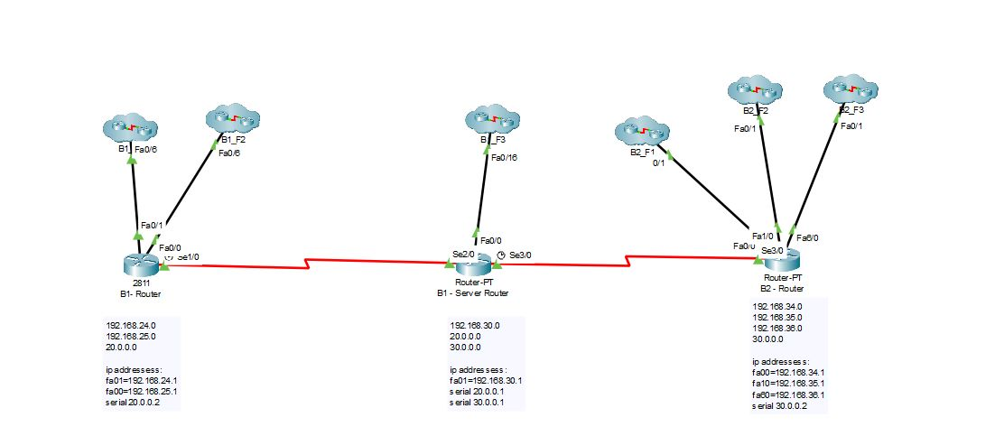

**General Design of the System**

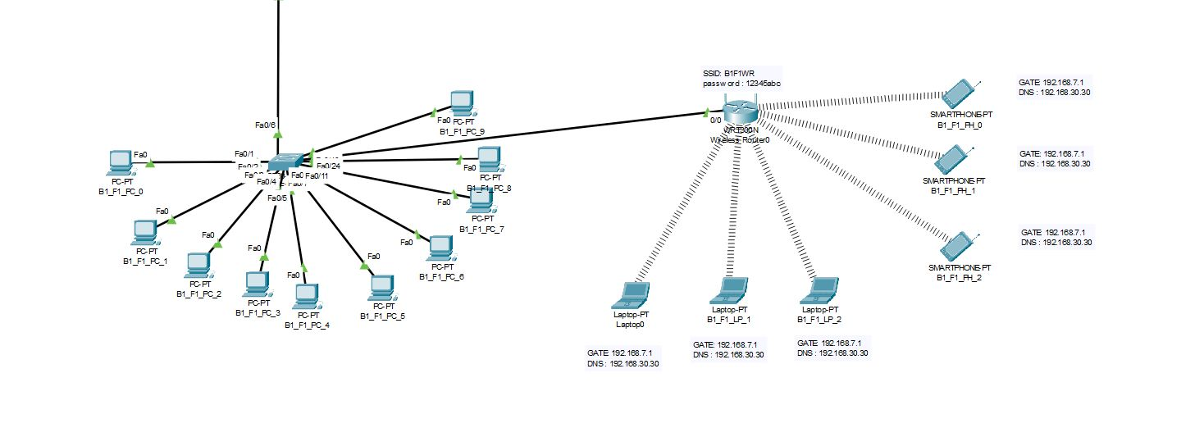

**First Branch First Facility**

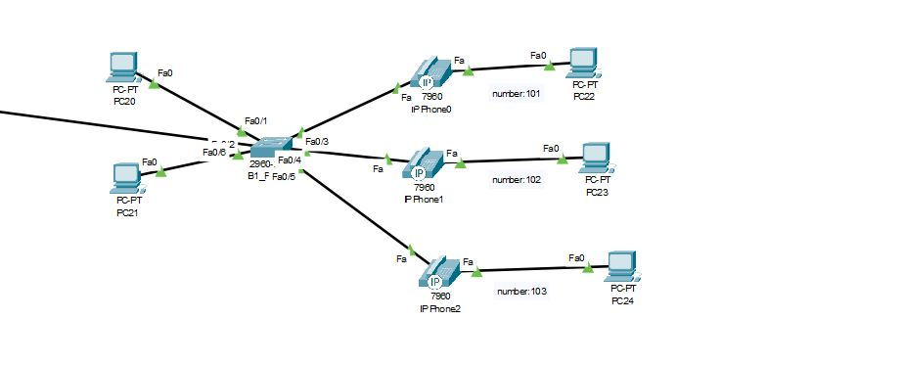

**First Branch Second Facility**

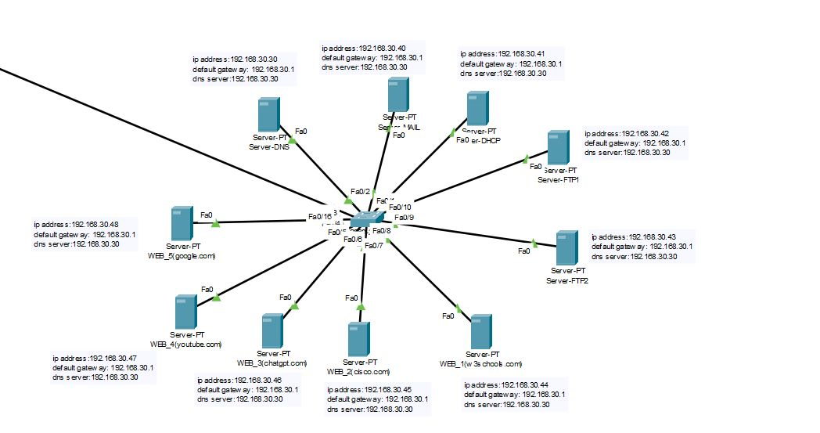

**First Branch Third Facility**

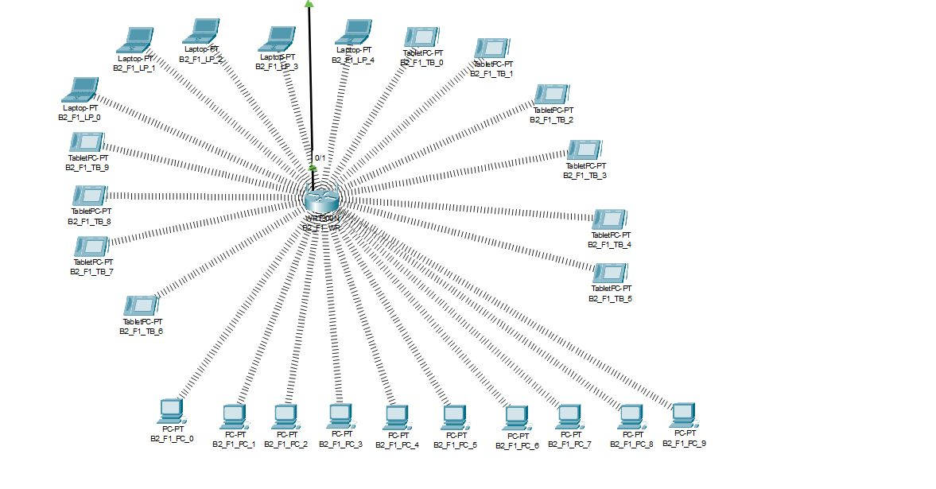

**Second Branch First Facility**

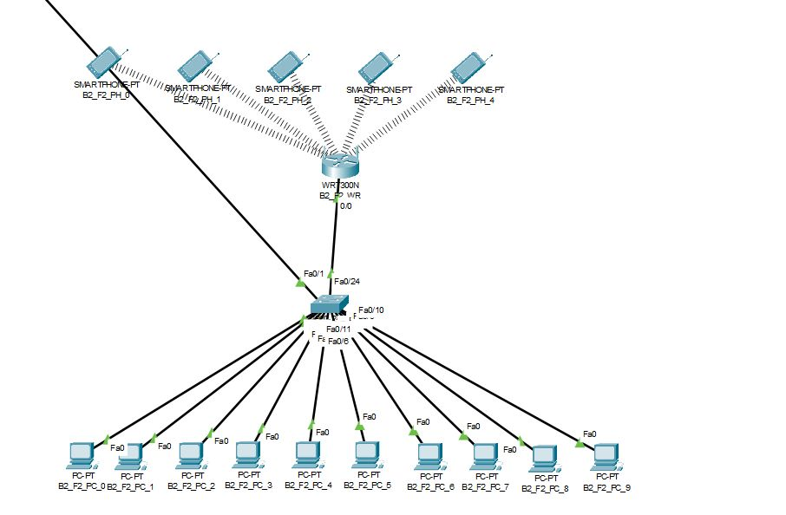

**Second Branch Second Facility**

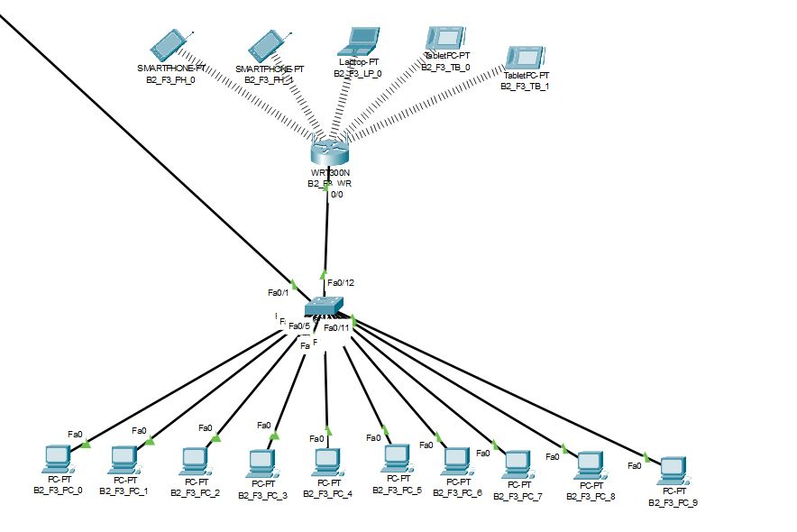

**Second Branch Third Facility**

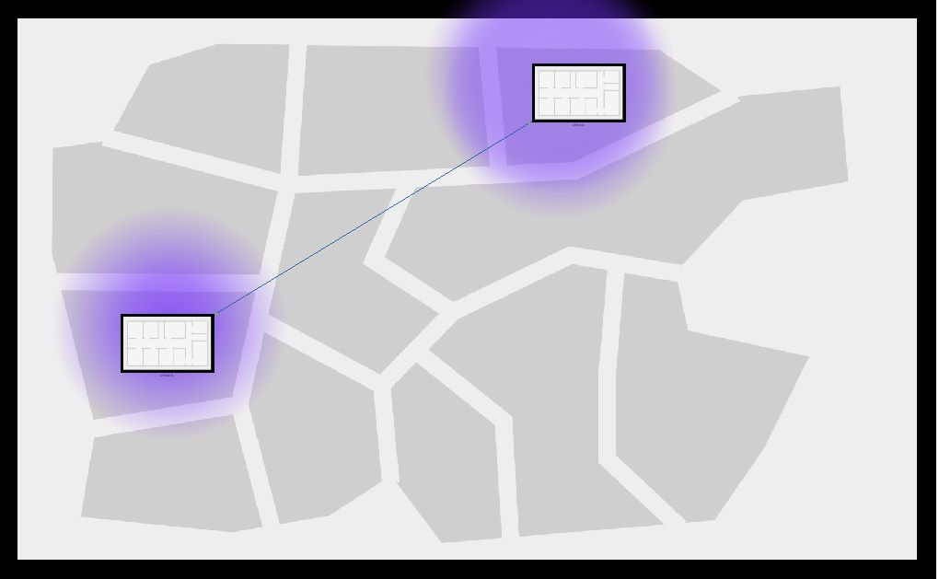

**Physical Design of the System**

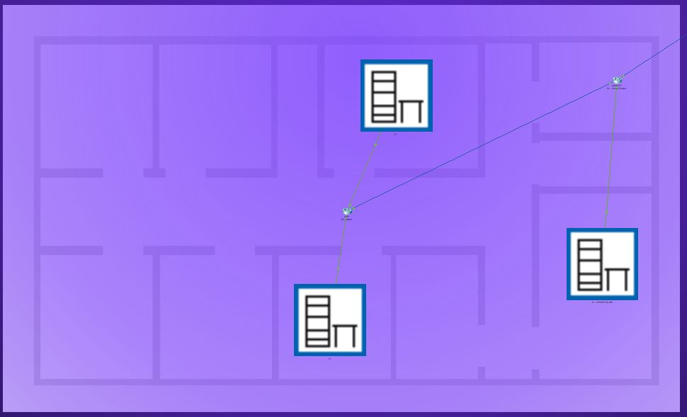

**First Branch**

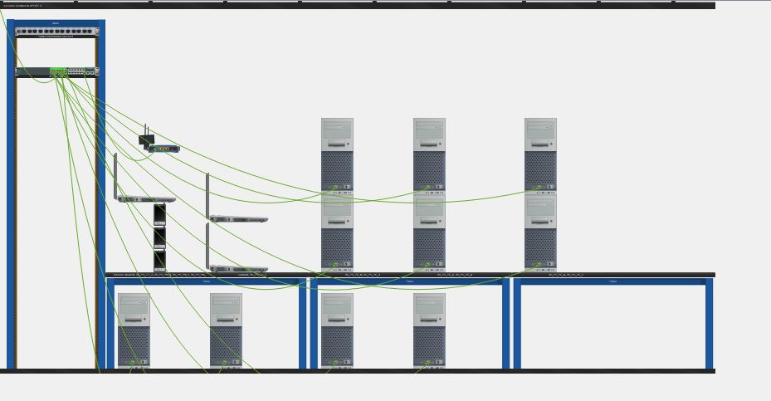

**First Branch First Facility**

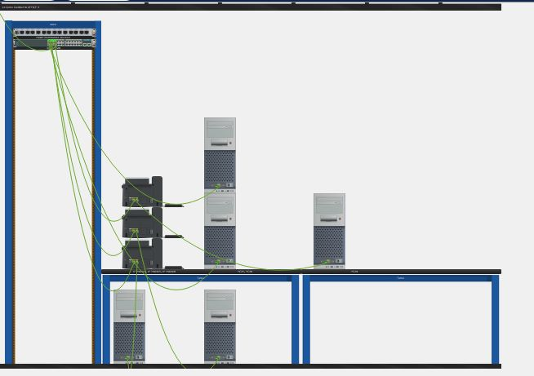

**First Branch Second Facility**

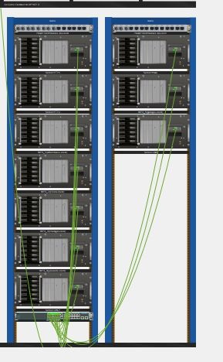

**First Branch Third Facility - Server Room**

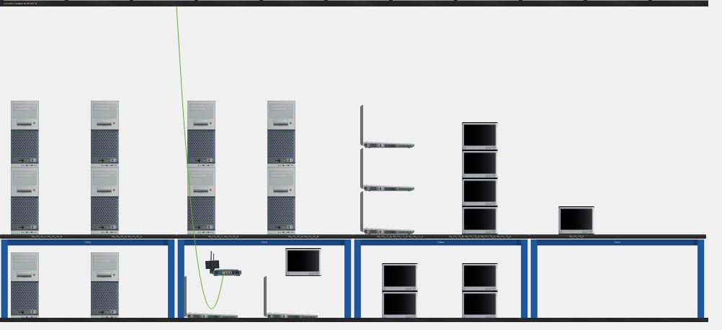

**Second Branch First Facility**

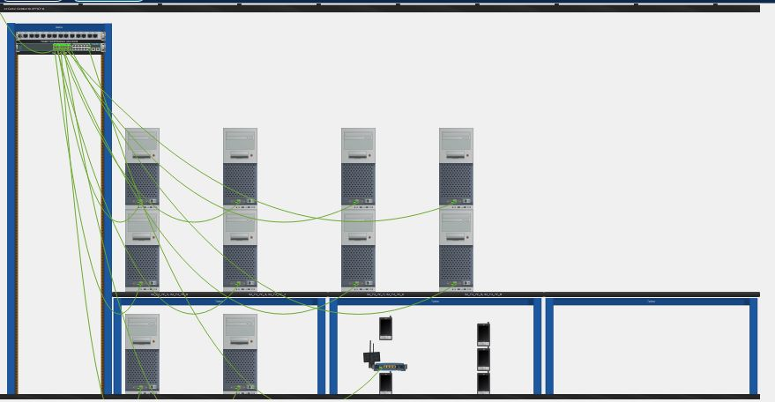

**Second Branch Second Facility**

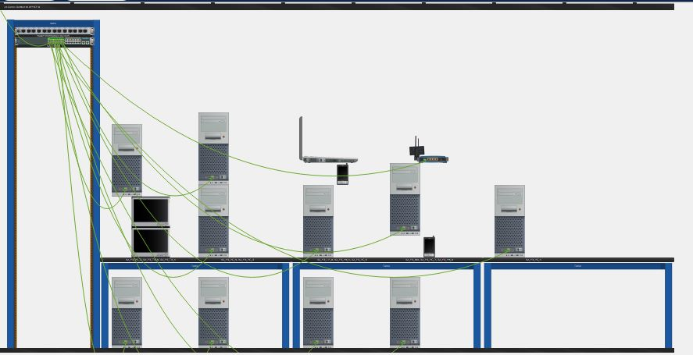

**Second Branch Third Facility**

## **2.6. Simulation Elements**

**System entities:**

* computer nodes
* routers
* wireless access points
* servers (Web servers, FTP servers, DHCP server, mail server, domain name server)
* workstation (PC) users
* wireless users (laptop, smartphone, tablet)
* mobile devices

**System state variables:**

* status of the channels (either idle or busy)
* status of the servers (available or busy)
* network traffic load
* network congestion
* packet drop rate

**Input variables:** arrival rate of packets

* service rate of servers
* bandwidth capacity of network links
* packet size
* packet transmission time
* packet delay time

**Resources**:

* bandwidth capacity of network links
* number of servers
* server processing capacity
* server storage capacity

**Activities and events:**

* packet transmission
* packet reception
* packet queuing
* packet routing
* packet dropping
* server processing
* server storage
* network congestion
* network expansion

# **CHAPTER THREE**

# **Traffic Analysis and Simulation Results**

## **Scenario 1:**

A wireless user from first facility of second branch wants to read emails and browse Web.

The process of reading emails involved communication between the user of Laptop 4 and the mail server, following a network path that included B2_F1_LP_4, B2_F1-WR, B2_F1_SW, B2-Router, B1-ServerRouter, Server Switch, and Mail_Server. This network path was traversed multiple times to complete the scenario.

Similarly, to browse the web, communication was established between the user of Laptop 4 and the web server, following a network path that included B2_F1-LP_4, B2_F1_WR, B2_F1_SW, Branch2-Router, B1-ServerRouter, and WEB. This network path was also repeated multiple times to complete the scenario.

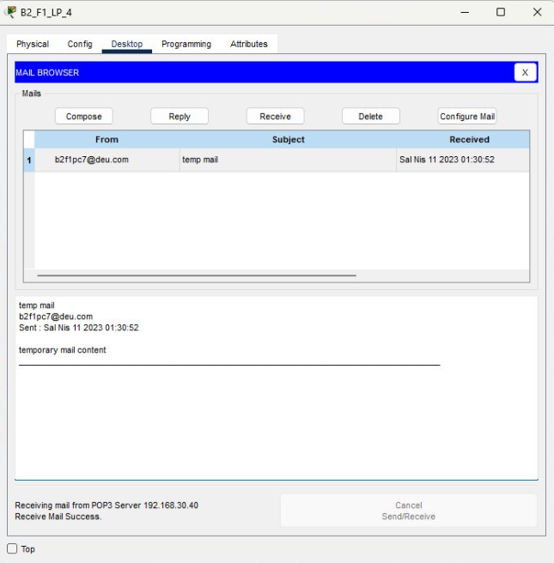

**Result of Scenario-1 for Read E-Mail**

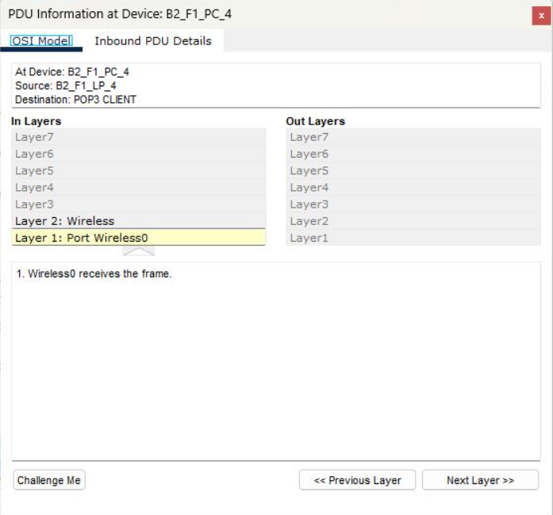

**OSI Model of Scenario-1 for Read E-Mail**

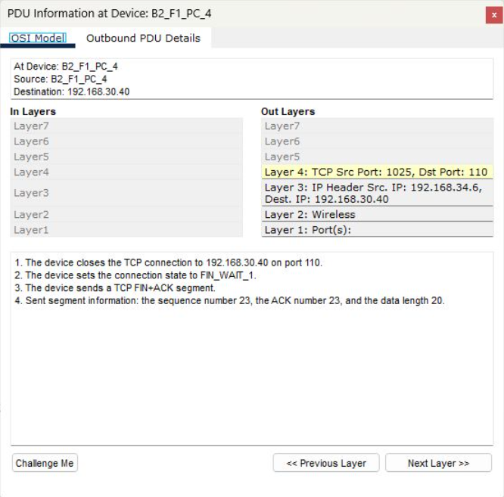

**OSI Model of Scenario-1 for Read E-Mail (The next step after doing read mail)**

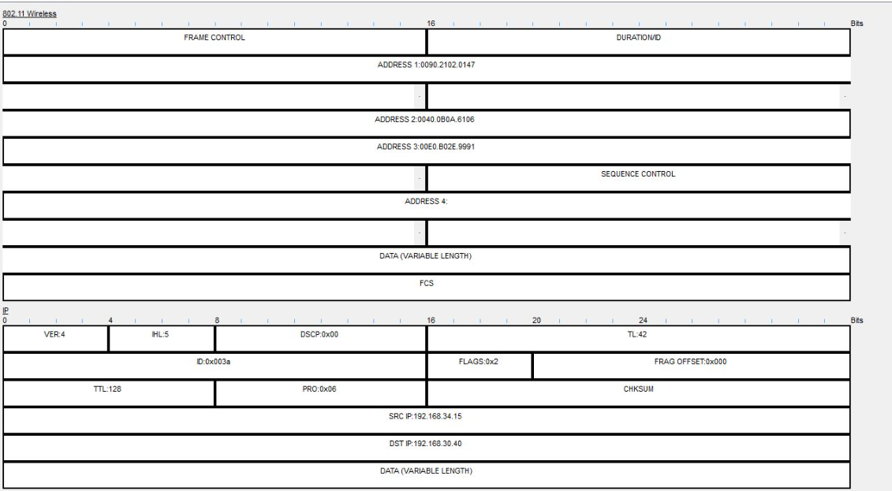

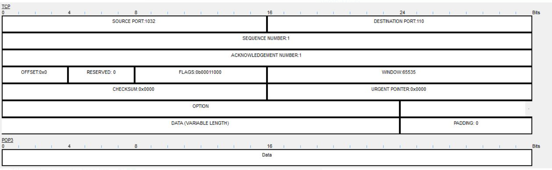

**PDU Output of Scenario-1 for read E-Mail**

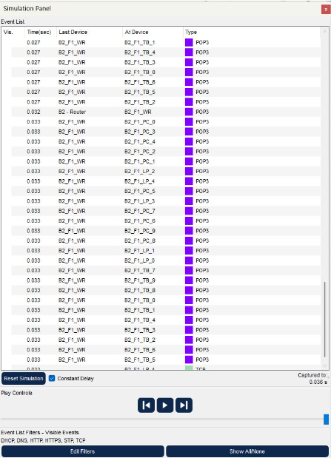

**Event List of Scenario-1 for Read E-Mail**

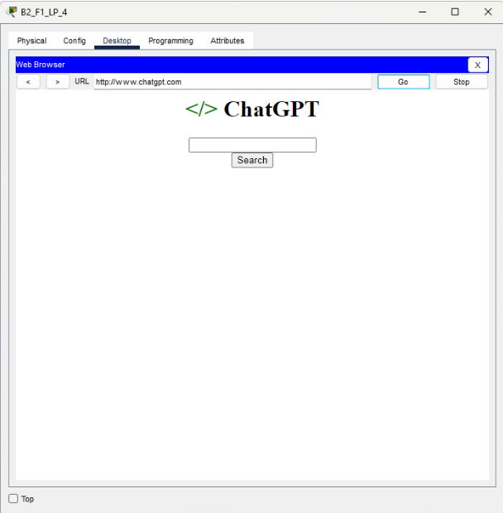

**Result of Scenario-1 for Browse Web**

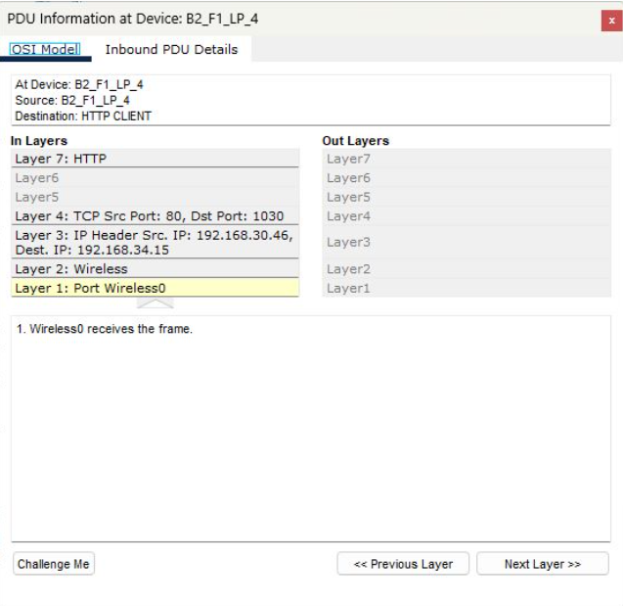

**OSI Model of Scenario-1 for Browse Web**

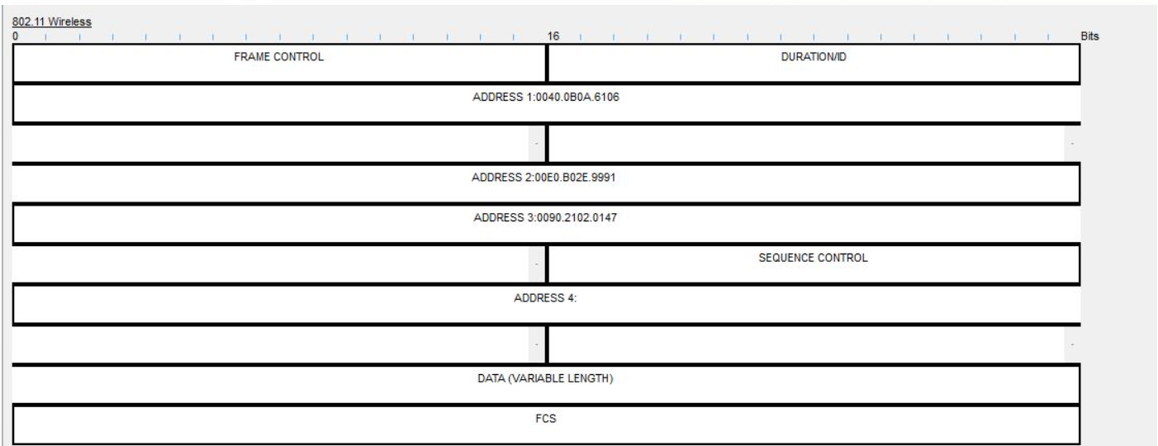

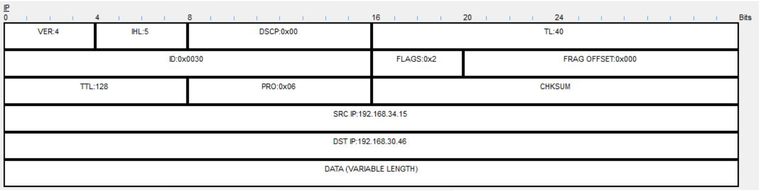

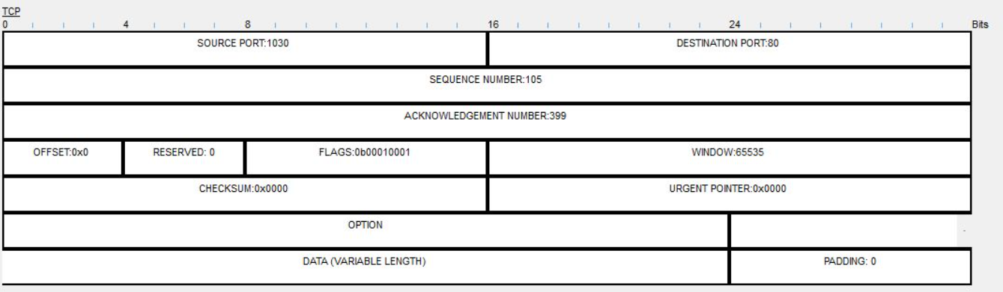

**PDU Output of Scenario-1 for Browse Web**

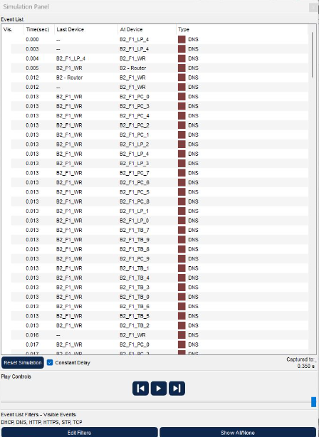

**Event List of Scenario-1 for Browse Web**

## **Scenario 2:**

A computer engineer from second facility of second branch developed a web application and wants to send his/her code files to FTP server in the third facility of first branch.

A network connection was established between the PC_0 user and the FTP server. To send files to the FTP server, the network path followed included B2_F2_PC_0, B2_F2_SW, B2-Router, B1-ServerRouter, B1_F3_SW, FTP_1, Server Switch, B1-ServerRouter, B2-Router, B2_F2_SW, and finally, the FTP server of the PC_0 user. This network path was traversed multiple times until the file transfer process was completed.

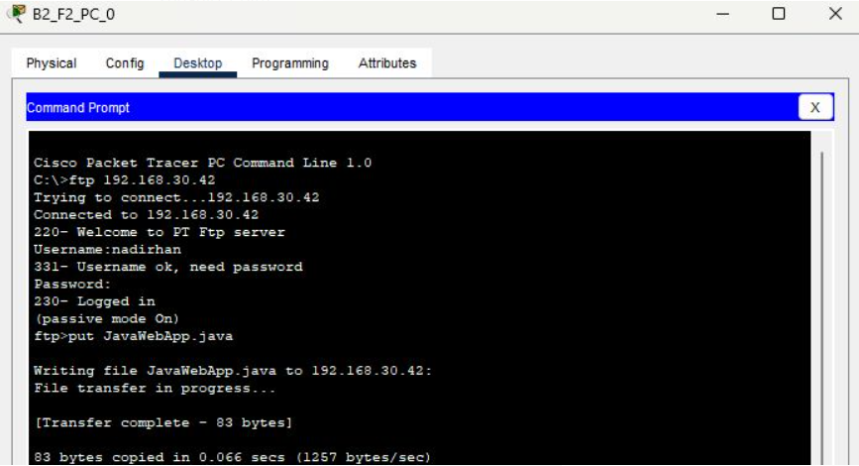

**Result of Scenario-2**

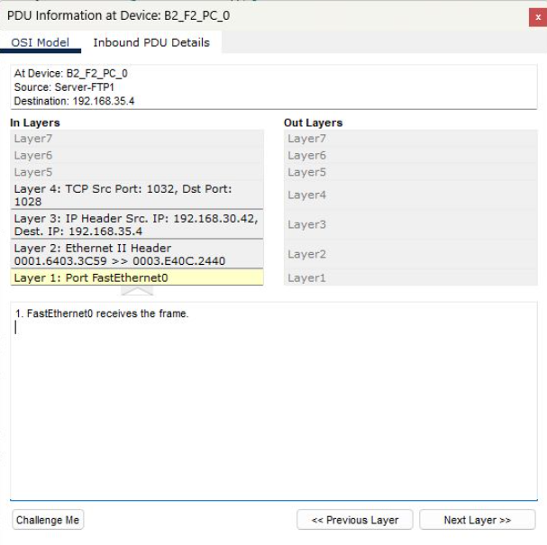

**OSI Model of Scenario-2**

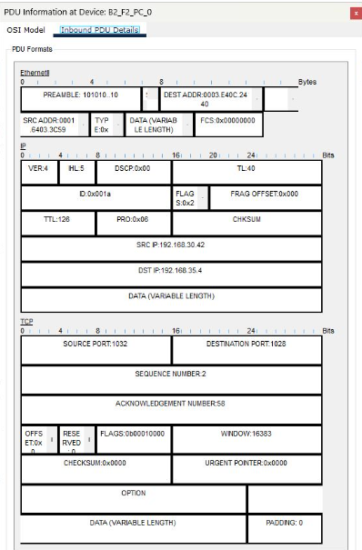

**PDU Output of Scenario-2**

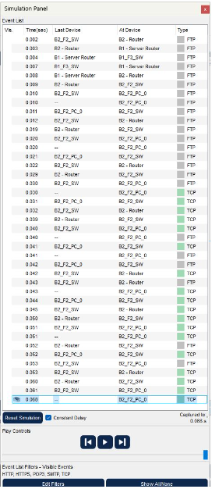

**Event List of Scenario-2**

## **Scenario 3:**

Two users from second facility of first branch want to talk via VoIP.

An IP Phone conference was conducted between IP Phone(0) user and IP Phone(1) user. The network path followed for this scenario included B1_F2-SW, B1-Router, B1_F2-SW, IP Phone(0), B1_F2-SW, B1-Router, B1_F2-SW, IP Phone(1), and IP Phone(0). This network path was repeated twice for IP Phones, including Branch1-Router, IP Phone(0), and IP Phone(1), to complete the conference.

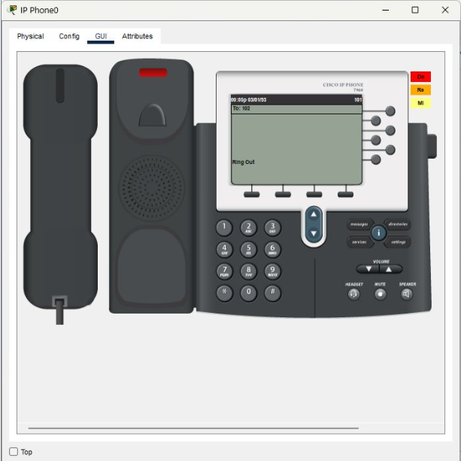

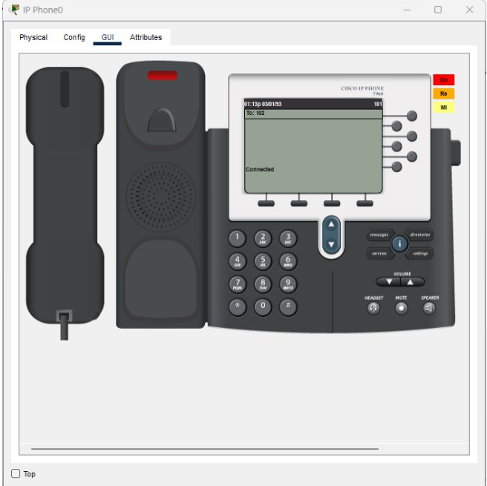

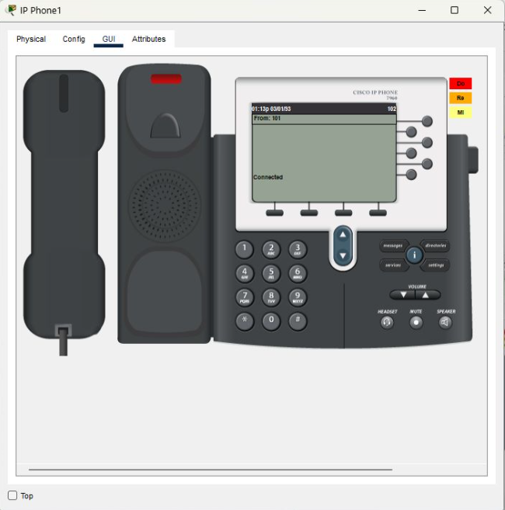

**Result of Scenario-3**

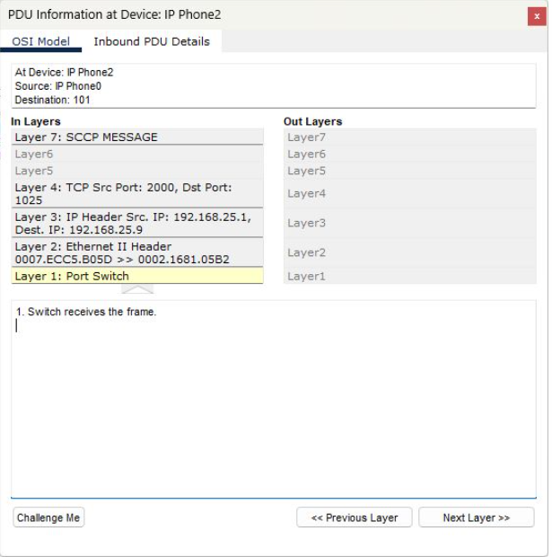

**OSI Model of Scenario-3**

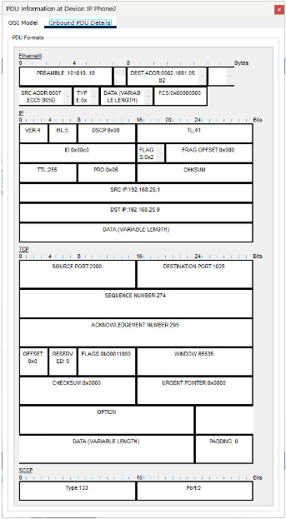

**PDU Output of Scenario-3**

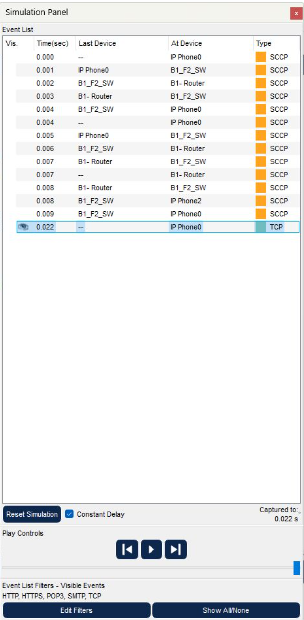

**Event List of Scenario-3**

## **Scenario 4:**

A user in the second facility of first branch wants to send an email message to his friend in the second facility of second branch.

Users located in the second facility of the first branch and the second facility of the second branch are restricted from sending or receiving emails. As a result, the workstation user in the second facility of the first branch was unable to send an email to the workstation user in the second facility of the second branch.

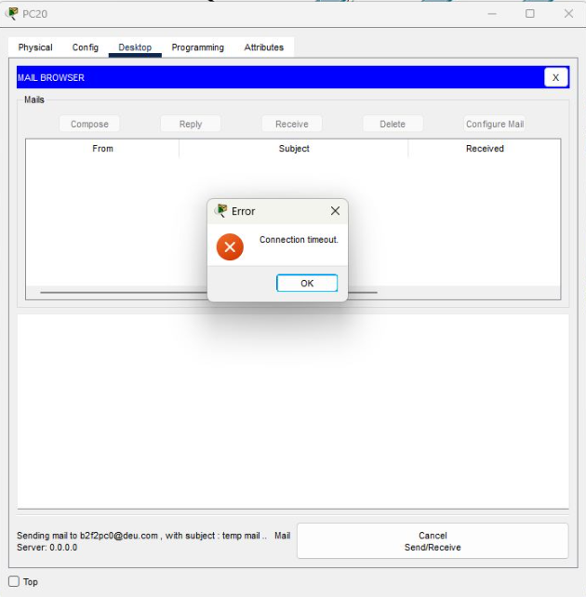

**Result of Scenario-4**

## **Scenario 5:**

A user from first facility of second branch pings Web server of second facility of first branch.

A ping was initiated between the B2_F1_TB_5 user and the web server, following the network path of B2_F1_TB_5, B2_F1_WR,B2-Router, B2_F1_WR,B2_F1-SW, B2_F1_WR.

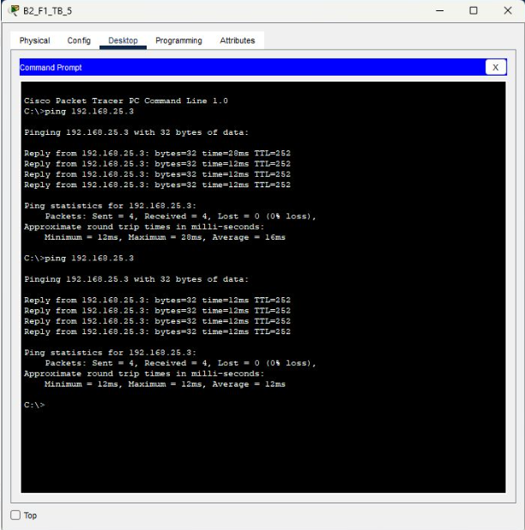

**Result of Scenario-5**

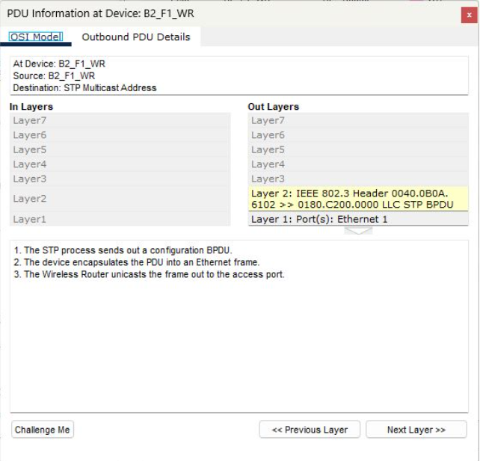

**OSI Model of Scenario-5**

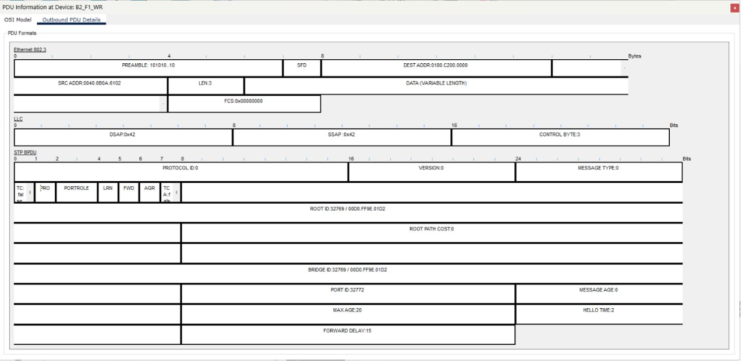

**PDU Output of Scenario-5**

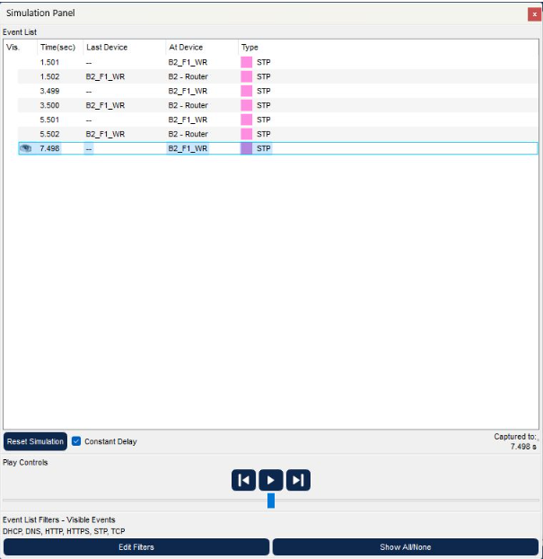

**Event List of Scenario-5**

## **Scenario 6:**

A laptop user from first facility of first branch office wants to send email to her friend in the first facility of second branch office.

When “B1_F1_LP_2” in the first facility of the first branch sends an email to “b2f1lp3@deu.com” in the first facility of the second branch, the email goes through multiple routers and switches. The Wireless Router for Laptop and Smartphones and B1_F1_SW in Workstations cluster are the first to receive the email.

The email then proceeds to the B1-ServerRouter and onto the B1_F3(SERVERS) cluster, where it reaches the Server Switch inside. The server user’s name and domain name are determined, after which the mail is sent to the Mail Server. The email then passes through the Server Switch, the B1-ServerRouter, and the common router of facilities in the second branch to reach the B2-Router.

Using the IP address of the recipient, the email locates the B2_F1-SW within the cluster of the first facility of the second branch. Finally, the email reaches the computer of the intended recipient, named “b2f1lp3,” which is also known as B2_F1_LP_3.

Throughout this process of sending the email, various protocols such as DHCP, DTP, STP, TCP, and SMTP play a role.

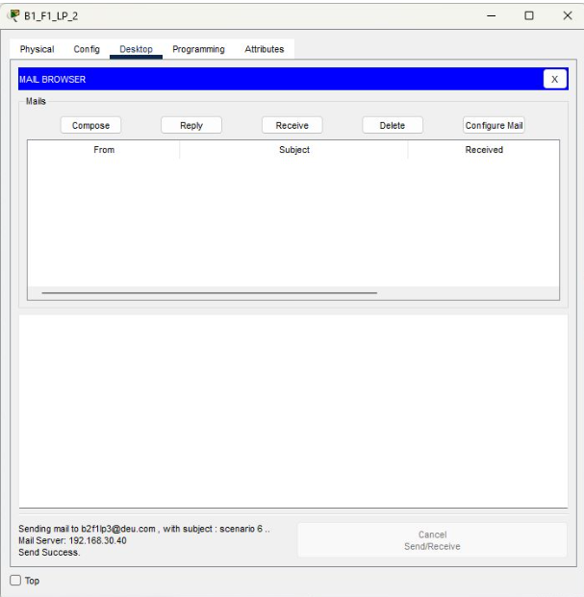

**Result of Scenario-6**

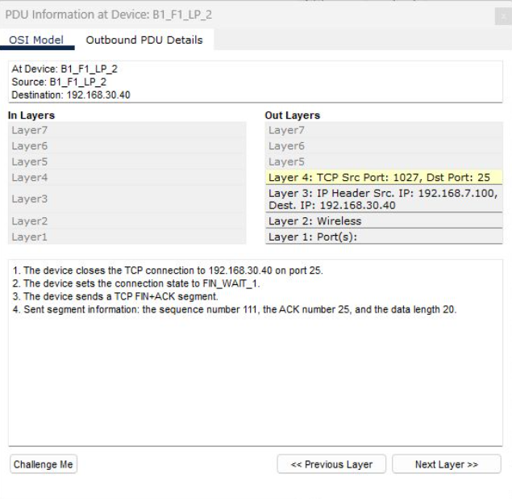

**OSI Model of Scenario-6**

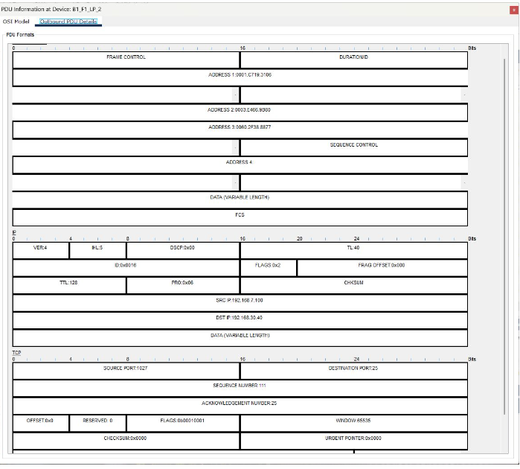

**PDU Output of Scenario-6**

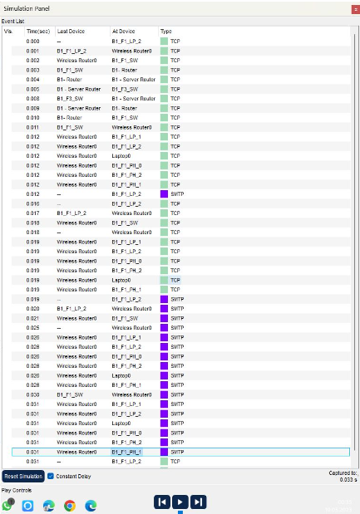

**Event List of Scenario-6**

## **Scenario 7:**

A smartphone user from third facility of second branch office wants to use ssh to connect to a Web server in the third facility of first branch office.

An ssh request was sent to 192.186.30.1, positive respond is returned if ssh is passed. One of the web servers was pinged in ssh mode. Following the network path of B2-Router, B1-Server Router,B2_F3_SW and B2-Router.

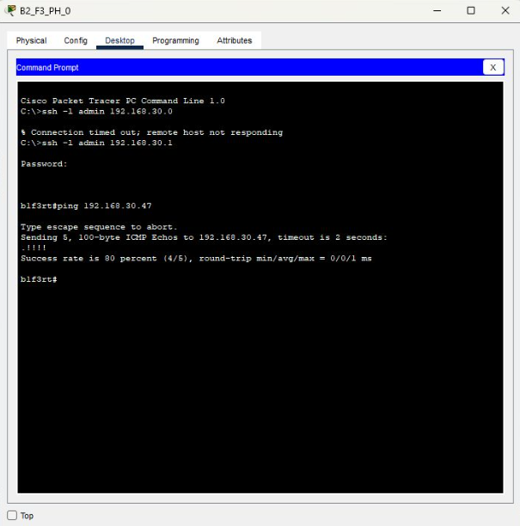

**Result of Scenario-7**

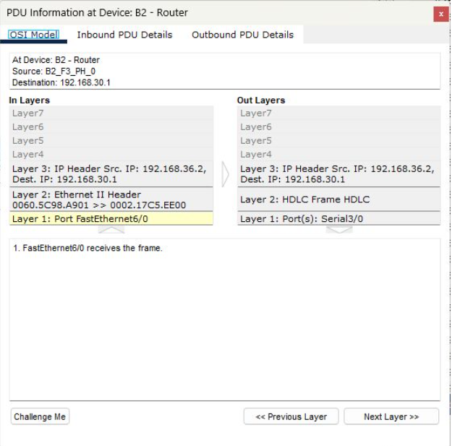

**OSI Model of Scenario-7**

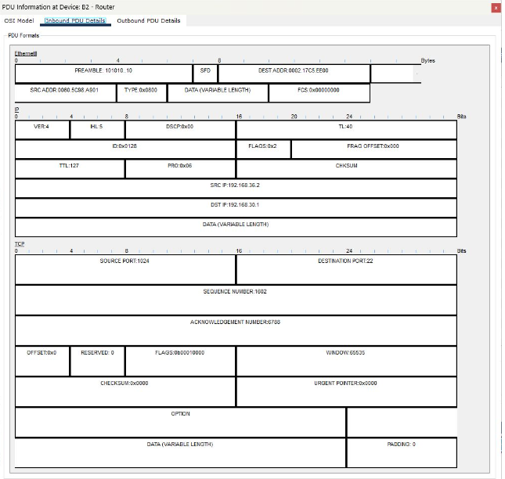

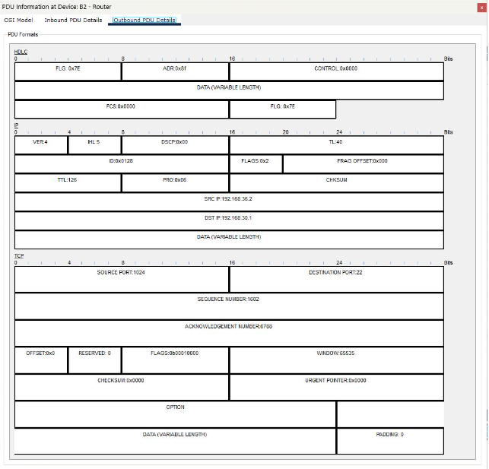

**PDU Output of Scenario-7**

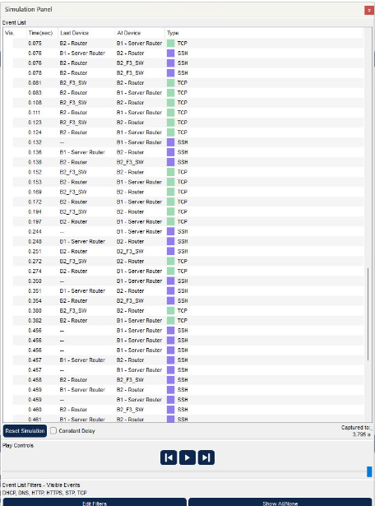

**Event List of Scenario-7**

## **Scenario 8:**

Two users from second facility of first branch want to talk via VoIP without unidentified number.

During the VoIP conference, the IP Phone(0) user attempted to connect with an unidentified number (107), resulting in an unknown number notification. The network path taken by the call is B1F2-Switch, IP Phone(0), B1-Router, B1_F2_Switch, B1-Router, and IP Phone(0).

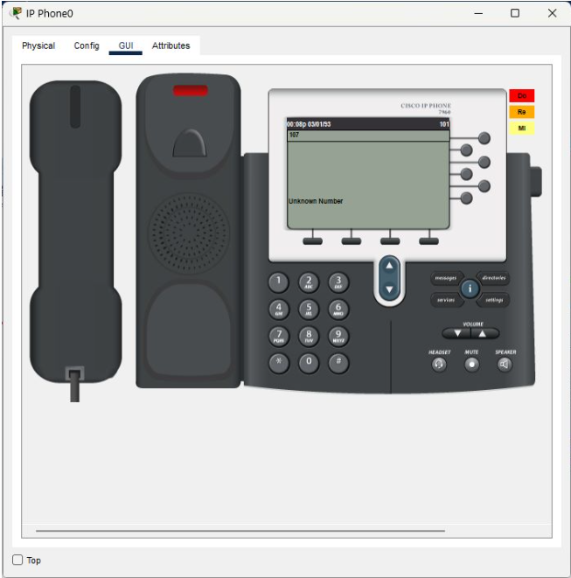

**Result of Scenario-8**

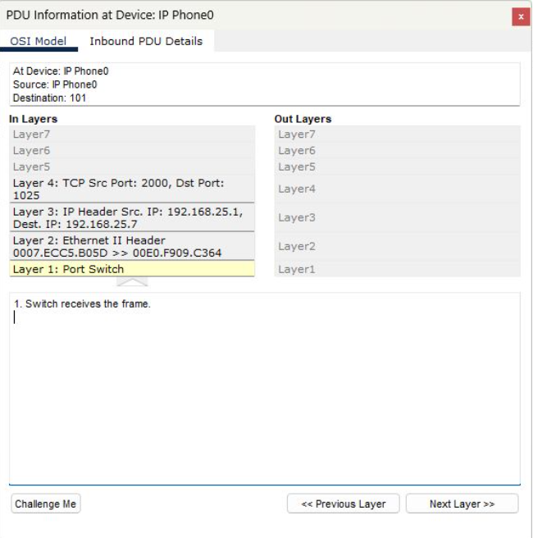

**OSI Model of Scenario-8**

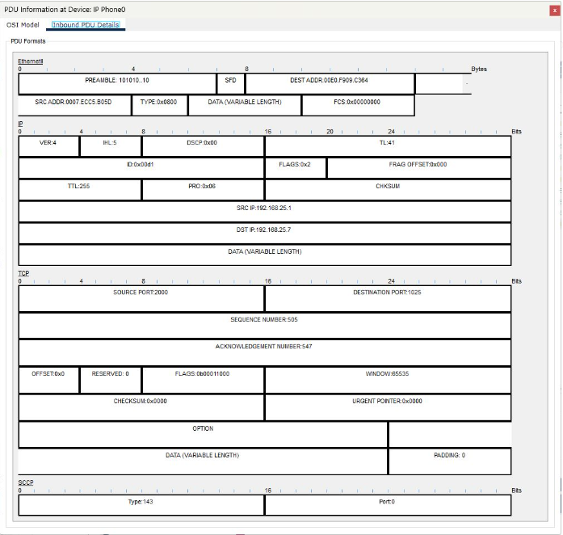

**PDU Output of Scenario-8**

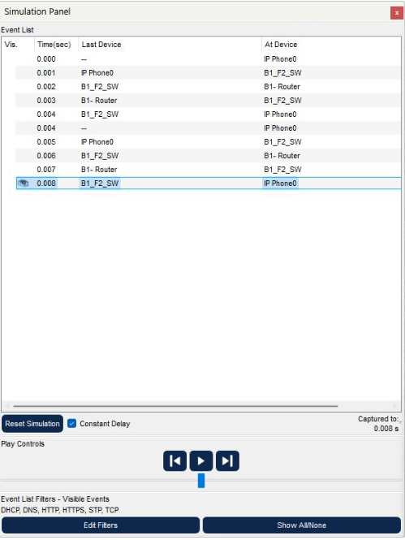

**Event List of Scenario-8**

## **Scenario 9:**

A computer engineer from first facility of second branch developed a web application

and wants to send his/her code files to FTP server in the third facility of first branch.

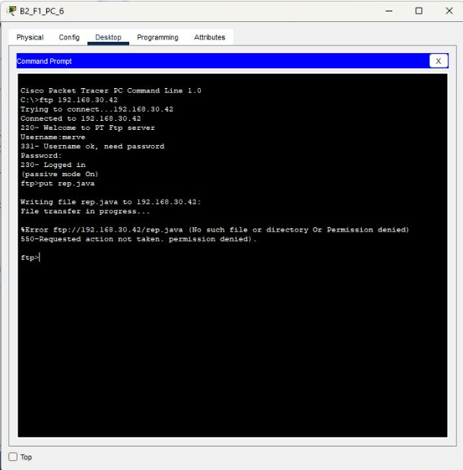

**Result of Scenario-9**

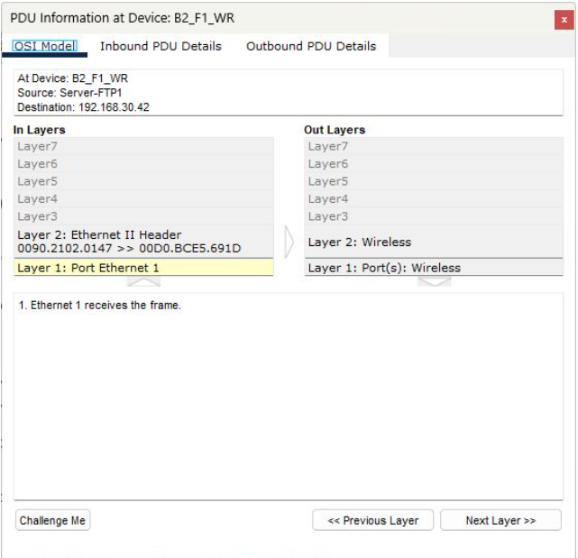

**OSI Model of Scenario-9**

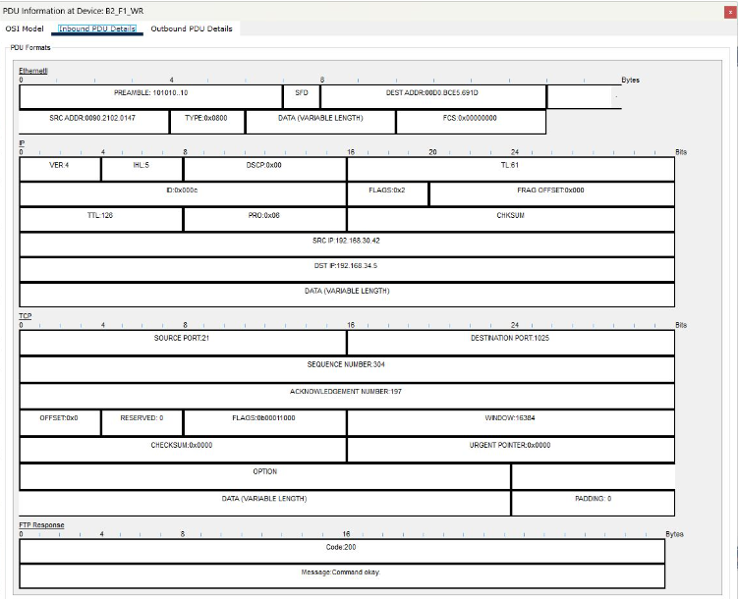

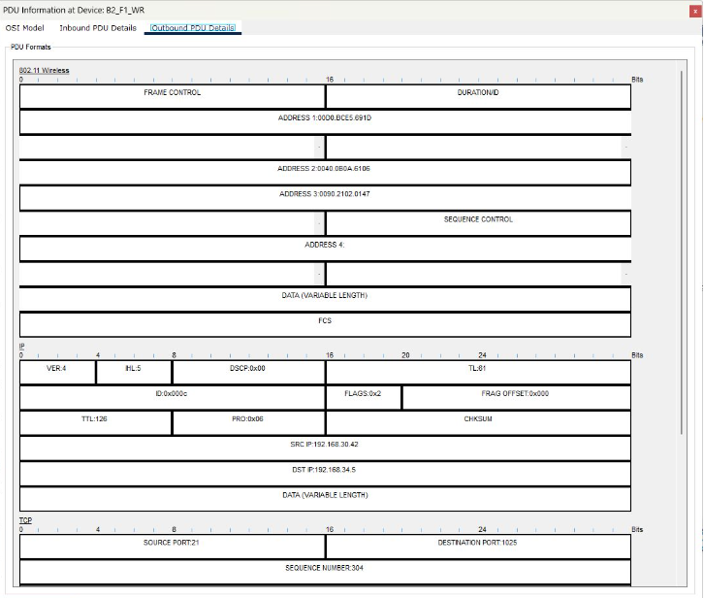

**PDU Output of Scenario-9**

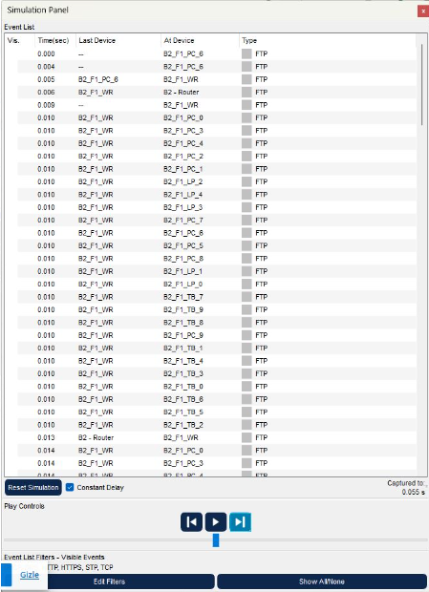

**Event List of Scenario-9**

# **CHAPTER FOUR**

# **Conclusion**

In this project, we have designed a Metropolitan Area Network (MAN) by using Cisco Packet Tracer software. The network consists of two branches, each comprising of three facilities with different units and requirements. The first branch has 10 workstation users, 3 wireless users, and 3 smartphones users in the first facility, 5 workstation users with 3 of them used for VoIP conference events in the second facility, and a server farm including 5 Web servers, 2 FTP servers, 1 DHCP server, 1 mail server, and 1 domain name server (DNS) in the third facility. The second branch includes 10 workstation users, 5 wireless users and 10 tablet users ,10 workstation users and 5 smartphone users and 10 workstations and 5 mobile devices in each facility respectively. Our design includes at least two routers for each branch and connection technologies between ISP and branches to meet the network requirements and specifications. Through this project, we successfully implemented a well-designed computer network architecture that supports the maximum number of network users, traffic load with minimum delay, and adequate hardware support for network expansions while keeping the balance between the cost of network hardware and the system requirements.

# **CHAPTER FIVE**

# **References**

[1] For the general description of computer network planning and design:

Tanenbaum, A. S., Wetherall, D. (2011). Computer Networks (5th ed.). Pearson.

[2] For definitions of common networking terms:

Cisco. (n.d.). Networking Terms Glossary. Retrieved from https://www.cisco.com/c/en/us/support/docs/dial-access/asynchronous-connections/10029-glossary.html

[3] Wehrle, K., Güneş, M., & Gross, J. (Eds.). (2010). Modeling and tools for network simulation. Springer Science & Business Media.

[4] Guizani, M., Rayes, A., Khan, B., & Al-Fuqaha, A. (2010). Network modeling and simulation: a practical perspective. John Wiley & Sons.

[5] NIST. (n.d.). Machine learning in network modeling and simulation. Retrieved from https://www.nist.gov/programs-projects/machine-learning-network-modeling-and-simulation

[6] Configuration of SSH on Cisco Switch in Packet Tracer - W7cloud : https://w7cloud.com/configuration-of-ssh-on-cisco-switch/

[7] Configurar SSH en Router Cisco Packet Tracer - YouTube : https://www.youtube.com/watch?v=eVth4xXqnxg

[8] Cisco Router/Switch SSH konfigürasyonu - Salih Altuntaş (salihaltuntas.com):https://salihaltuntas.com/cisco-router-switch-ssh-konfigurasyonu/

[9] DHCP - Configuring the Cisco IOS DHCP Server [Support] - Cisco Systems: https://www.cisco.com/en/US/docs/ios/12_4t/ip_addr/configuration/guide/htdhcpsv.html#wp1143732

[10] Cisco Router DHCP Yapılandırma: https://www.firatboyan.com/cisco-router-uzerinde-dhcp-ayarlari-yapilandirma.aspx

[11] Simple PDU - YouTube:https://www.youtube.com/watch?v=NmMzIH0alV8&t

[12] DHCP DNS and Web Server configuration in cisco packet tracer : https://www.youtube.com/watch?v=NmMzIH0alV8&t

[13] Packet Tracer Student: DHCP and DNS:https://www.youtube.com/watch?v=7OxAKmFcvBk&t

[14] FTP Server Cisco Packet Tracer:https://www.youtube.com/watch?v=MPTrbFzIn0Y

[15] Email Server Configuration in Cisco Packet Tracer | Cisco Packet Tracer Email Server || Mail Server : https://www.youtube.com/watch?v=kVVZ1JAbOoI&t

[16] Subnet Mask Nedir ? : https://www.youtube.com/watch?v=FTWfCY-I7MY

[17] Subnet Mask - Explained : https://www.youtube.com/watch?v=s_Ntt6eTn94

[18] 01 - IP Subnetting Nedir ? Network ve Broadcast Adresini Bulma : https://www.youtube.com/watch?v=4s_odShdVYs&t